

RAJOKRI INSTITUTE OF TECHNOLOGY, DSEU



**EXCEL PRACTICAL FILE**

**Name**: Pawan Parida  
**Roll No**: 231112028098

**Course**: Bsc Data Analytics

**Semester**: Second

**Submitted to** : Dr. Shilpa Bahl Mam

**Lab Index Advanced Excel**

|  |  |  |
| --- | --- | --- |
| P.No | Aim | Date |
| 1 | Create a data for a class with 5 Students with Roll No, Name, Mobile Number and DoB applying Data Validation on each field accordingly | 8/4/24 |
| 2. | Create a data for a grocery shop analysing the sales for a week by adding product id, product name, product price, Number of items sold in a day, total sales in the current week, total sales in previous week, Demand, Supply. Apply countif and conditional formulas to make decision to order the item from the vendor or not. | 9/5/24 |
| 3 | Create a table with data as Roll No,First Name,Last Name,Course,Phone Number and apply LOOKUP, VLOOKUP and HLOOKUP on the data | 15/4/24 |
| 4 | Show the Implementation of Macros | 22/4/24 |
| 5 | Create a sales data to show the implementation of Goal Seek | 29/4/24 |
| 6 | Create a data with employees’ salary and his/her monthly expenditures, and implement scenario manager to create three different scenarios if the salary increases. | 29/4/24 |
| 7 | Create a data for employee details for ten employees as employee id, employee name, contact details, salary, Pan no and address …apply four methods for data cleaning | 12/5/24 |
| 8 | Create a data for employee details for ten employees as employee id, employee name, contact details, salary, Pan no and address …apply four methods for data cleaning | 12/5/24 |
| 9 | Create a data for employee details for ten employees as employee id, employee name, contact details, salary, Pan no and address …apply four methods for data cleaning | 12/5/24 |
| 10 | Create a data to implement MATCH function and INDEX Function. | 20/5/24 |
| 11 | Create a data and implement IFNA and IFERROR functions | 20/5/24 |
| 12 | Create a data and implement IF, Nested if and Logical function AND and OR with IF | 20/5/24 |

**Practical 1**

1. Create a data for a class with 5 Students with Roll No, Name, Mobile Number and DoB applying Data Validation on each field accordingly.

We would first need to create a table with atleast 5 students rollno, name, mob_number and DOB, and then would see how to apply data validations.

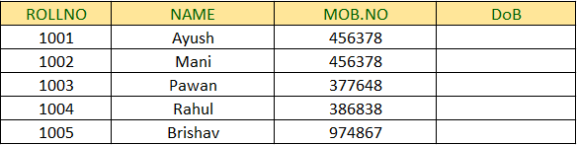

Now follow the following steps below:

**Step 1**. Select the cell of column where you want to apply the Data Validation.

**Step 2**. Go to Data Tab in Excel.

**Step 3**. Select Data Validation option.

**Step 4.** A window opens up, where you see 3 tabs as Settings, Input Message and Error alert

**Step 5**. First set the settings as according to the requirement, for example: if we want to apply for the rollno column data validation, we would first in Setting tab select Whole number for Rollno and provide it with geater than data value and then go to input message tab and give input message accordingly the settings you have set and then finally apply error alert message, where if someone gives eventhough wrong input then it pops the error alert.

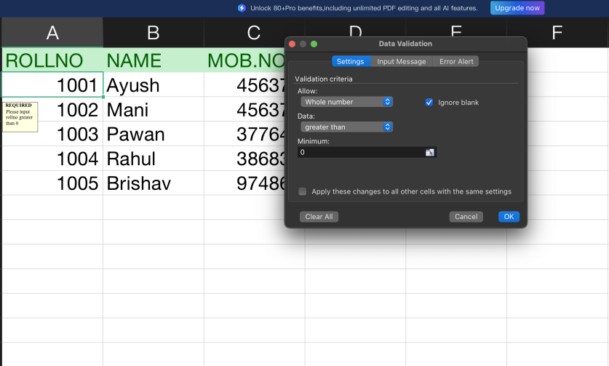

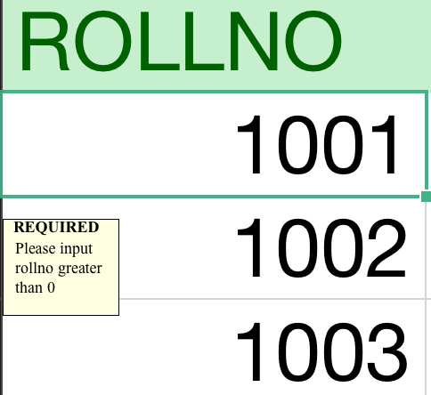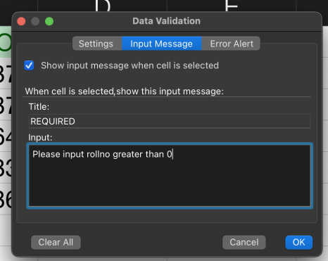

Here it shows as like input message

The Data Validation is more helpful is receiving most accurate entries and guiding the user to input correct values to the columns.

**Practical 2**

1. Create a data for a grocery shop analysing the sales for a week by adding product id, product name, product price, Number of items sold in a day, total sales in the current week, total sales in previous week, Demand, Supply. Apply count-if and conditional formulas to make decision to order the item from the vendor or not.

Ans -

**Step 1: Create the Dataset**

Create an Excel sheet with the following columns:

1. Product ID
2. Product Name
3. Product Price
4. Number of Items Sold (for each day of the week)
5. Total Sales in Current Week
6. Total Sales in Previous Week
7. Demand
8. Supply
9. Order Decision

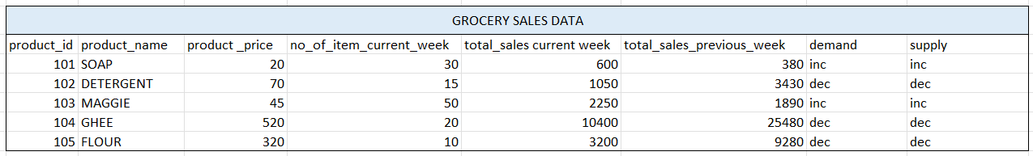

* In the Demand column, you can use a formula that reflects your business rules. For example, if demand is high when sales in the current week are more than the sales of the previous week, you could use the formula **=IF(D3>E3, "High", "Low")**.
* For Supply you might have a fixed amount for each product. If not, you can leave it blank for manual input.
* To decide whether to order more of a product, you could use a formula like =IF(D3-E3>=3, “Buy”, “Not Buy”) in a new column. This formula suggests ordering more if the current week's sales are less than the previous week's sales

**Practical 3**

1. Create a table with data as Roll No, First Name, Last Name, Course, Phone Number and apply LOOKUP, VLOOKUP and HLOOKUP on the data.

**Step 1: Create the Table**

First, create a table with the following data:

|  |  |  |  |  |
| --- | --- | --- | --- | --- |
| **Roll No.** | **First Name** | **Last Name** | **Course** | **Phone No.** |
| 101 | Ayush | Mishra | B.Sc. | 8373967263 |
| 102 | Brishav | Kumar | B.Sc. | 9643662498 |
| 103 | Mani | Sharma | B.Sc. | 8868963207 |
| 104 | Rahul | Sharma | B.Sc. | 8130747460 |
| 105 | Pawan | Parida | B.Sc. | 8700579954 |

The lookup function is used to find a value in row or column. There are two ways we can use Lookup function in excel.

1. **Vector Form:** The vector form of LOOKUP searches in a one-row or one-column range (known as a vector) for a value and returns a value from the same position in a second one-row or one-column range1.To get lookup value from a row or a column we use **Syntax** as :

=LOOKUP(lookup_value, lookup_vector, [result_vector])

**Lookup_Value:** A value that LOOKUP searches for in the first vector. It can be a number, text, a logical value, or a name or reference that refers to a value.

**Lookup_Vector:** A range that contains only one row or one column. The values in lookup_vector must be placed in ascending order.

**Result_Vector:** A range that contains only one row or one column. The result_vector argument must be the same size as lookup_vector.

EXAMPLE:

=LOOKUP(J4,A2:A6,C2:C6) and stretched the formula below for the same.

|  |  |
| --- | --- |
| Rollno | Last Name |
| 103 | Sharma |
| 104 | Sharma |

1. **Array Form :** The array form of LOOKUP can search for a value in multiple rows and columns2. It first locates the specified value in the first row or column of the selection and then returns the value of the same position in the last row or column2.

We can simply apply the simple syntax for Lookup as array , **Syntax:**

=LOOKUP(lookup_value, array)

lets see it with an example: =LOOKUP(F4, A2:A6), this always gives the last selected columns value from the array.

**VLOOKUP AND HLOOKUP**

1. **VLOOKUP :** The VLOOKUP function is used to search for a value in the first column of a table and return a value in the same row from another column.   
   Syntax: VLOOKUP(lookup_value, table_array, col_index_num)  
   This formula searches for the value 2 in the first column (A2:A6) and returns the value in the 3rd column (Last Name) in the same row, which is "Smith".

**Example:**  =VLOOKUP(3, A2:E7, 3)

|  |  |
| --- | --- |
| **VLookup** | |
| **Roll No.** | **Phone No.** |
| 102 | 9643662498 |

1. **HLOOKUP:** The HLOOKUP function is used to search for a value in the first row of a table and return a value in the same column from another row. Lets take an example to find the Course of the student whose Phone Number is 456-789-0123, for this we may prefer to use the HLOOKUP function in excel. But here for Hlookup we would need to create a horizontal table for the application as same as the given table above provided.

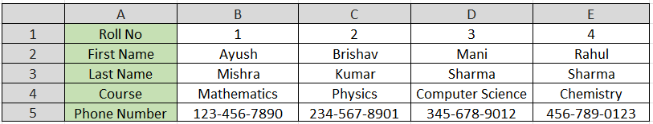  
  
**Syntax:** =HLOOKUP("456-789-0123", E1:E6, 4, FALSE)

|  |  |
| --- | --- |
| Phone No | Course |
| 345-678-9012 | Chemistry |

**Practical 4**

1. Show the Implementation of MACROS in Excel with explanation.

Macros can be considered as a set of programming instructions that can be recorded, named, saved, and executed in VBA as and when required macros can help us to automate repetitive tasks associated with data manipulation that must be accomplished repeatedly. You can also enable and disable macros in Excel.

**How to Turn on the Developer Tab in Excel**

The developer tab is hidden by default on the ribbon. To customize the Ribbon, Follow these steps:

STEP 1: Right Click on the Ribbon.

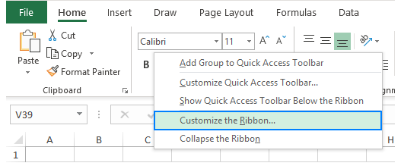

STEP 2: Navigate to customize ribbon and check for developer option.

**RECORDING ON EXCEL**

The Following steps can be performed to record a macro in Excel:

step 1: Click on the Developer Tab in the Ribbon.

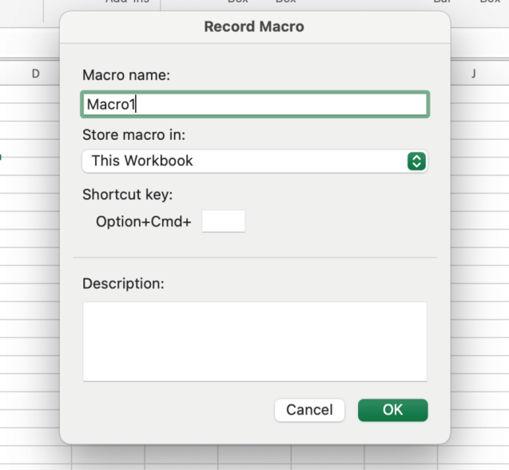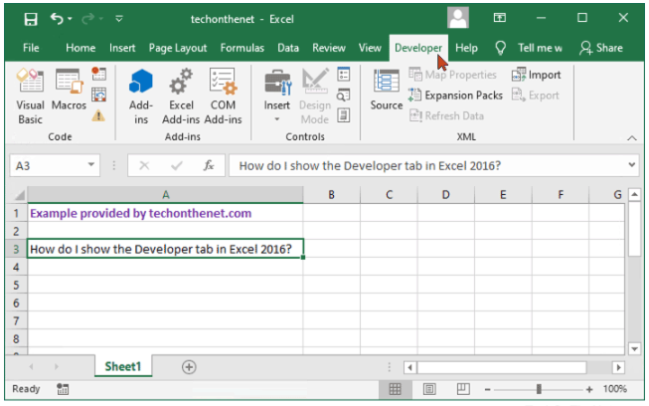

Step 2 : Click on record macro

Step 3 : Now fill the macro dialogue box

In the dialogue box, enter the name of macro in the Macro Name. However space cannot be used in Macro Name to seperate words. For example: Macro_name

There are some other option also in the dialogue box, i.e., where to store the macro, shortcut key which can be used to activate the macro.

Now after the Macro starts recording start your work as per your required and make actions on the sheet, it would record the actions each of them you take upon.

Once you are done with all your task, you ca stop recording macro from the ribbon at same tab.

We can run macro through different ways like by creating shape, button aur simply by clicking the shortcut key entered in dialogue box.   
lets see how we can use macros practically.....

Create a table of student class test report.

|  |  |  |
| --- | --- | --- |
| NAME | CLASS | Marks |
| Ayush | 5 | 74 |
| Pawan | 3 | 92 |
| Brishav | 4 | 84 |

Run macro you created and click on ‘Record macro’ and perform your action for example create a table like above.

then when you need the same format or action you can directly click the button you created like i create “option+command+g”.

then the whole same action would apply in seconds.

MACRO can be used in case like when a teacher is making report card of student on excel but he not wants to waste most of time in creating same format again and wants only to change name and marks once created, then he/she may use Macro in excel.

**Practical 5**

Q. Create a sales data to show the implementation of Goal Seek

In Excel sheet, enter the data:

Use of **Goal Seek**:-

1. Go to the ‘Data Tab’ in Excel.
2. Click on “what-if Analysis” in forecast group.
3. Choose Goal Seek From the dropdown menu.
4. In the ‘Set Cell’ field, enter the cell containing the formula you want to change.
5. In the “To Value” field, enter the desired value for the formula.
6. In the “by changing cell” field, enter the cell you want to change.
7. Click “OK” to run goal seek.

|  |  |
| --- | --- |
| Sales Items | Sales Value |
| Item price | ₹5.00 |
| Quantity | 50 |
| Commission | 10% |
| Revenue | ₹225.00 |

|  |  |
| --- | --- |
| Sales Items | Goal Seek |
| Item price | ₹5.00 |
| Quantity | 2222.222222 |
| Commission | 10% |
| Revenue | ₹10,000.00 |

Goal Seek helps us to achieve the target with the freedom to select the changing

variable. Goal seek helps only in one cell operations.

**Practical 6**

Q Create a data with employees’ salary and his/her monthly expenditures, and implement scenario manager to create three different scenarios if the salary increases.

### Step 1: Create the Data

First, create a table in Excel with columns for Employee Name, Current Salary, and Monthly Expenditures. For example:

|  |  |  |
| --- | --- | --- |
| Employee Name | Current Salary | Monthly Expenditure |
| Rakesh | $2,700 | $1,900 |
| Lakshmi | $3,800 | $2,700 |
| Pranav | $3,100 | $2,300 |
| Ananya | $4,300 | $2,900 |
| Divya | $3,000 | $2,600 |

**Step 2**: Implement Scenario Manager

1. Open Scenario manager-
2. Go to the Data tab on the Ribbon.
3. In the Forecast group, click on What-If Analysis.
4. Select Scenario Manager.
5. Add Scenarios-
6. In the Scenario Manager dialogue box, click “Add”.
7. Create Scenarios:
8. Scenario Name- Increase by 10%
9. Changing cell- select the cell which you want to be changed
10. Click “ok”’
11. In the Scenario Values dialog box, enter the new values by increasing each salary by 10%. For example, if B2 is $3,000, change it to $3,300. Repeat for all the other cells.
12. click “ok’

Similarly Create scenarios for 20% and 30% increase.

1. View scenarios:
2. In the Scenario Manager dialog box, select the scenario you want to view.
3. ·Click Show to see the effects of the scenario on the data.

### Step 3: Analyze the Scenarios

**Summary Report**:

1. In the Scenario Manager dialog box, click Summary.
2. Choose Scenario Summary.
3. Select the result cells you want to analyze. For example, select the cells that contain the total salaries and expenditures.
4. Click OK to generate a summary report.

The summary generated would look like this, although you prefer to change the name of columns shown in summary as per you. The summary helps in understanding of how to take up decision s per the scenario or condition for the data.

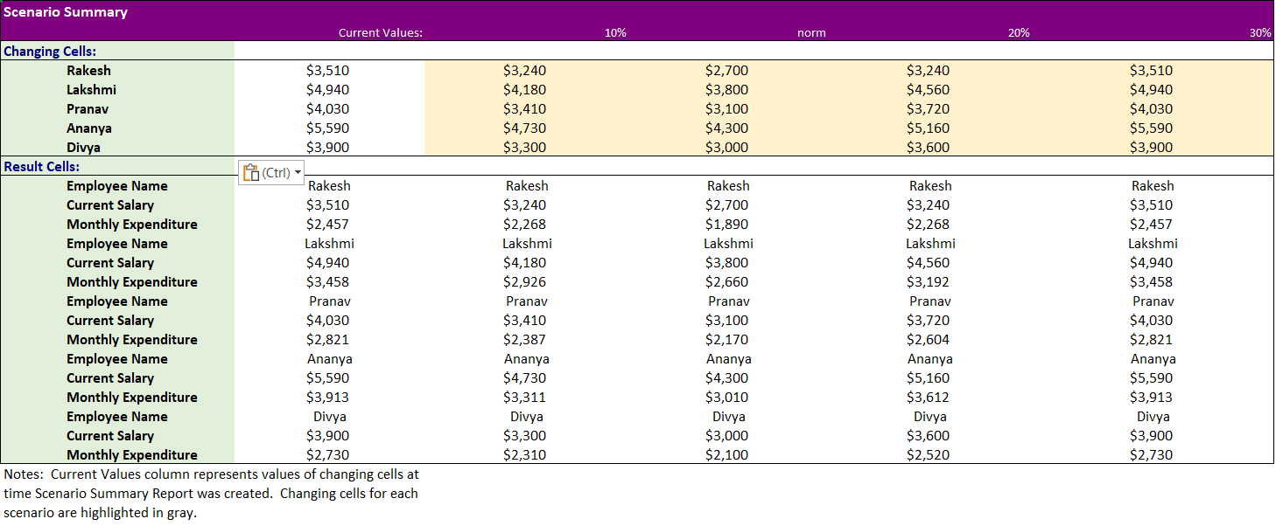

**Practical 7**

Create a data for employee details for ten employees as employee id, employee name, contact details, salary, Pan no and address …apply four methods for data cleaning.

Lets first create a table with guidance provided above and then apply data cleaning methods over it (four in this).

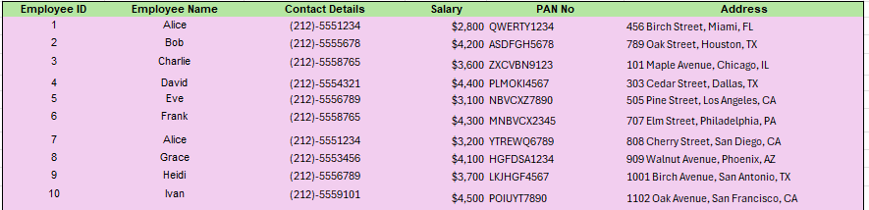

**Data Cleaning**: Data Cleaning in Excel is a combination of processes that includes identifying, highlighting, and acting against all kinds of errors to have organized data. There are many built-in Excel functions and features that are directly or indirectly used to ease the data-cleaning process in Excel.

**Method 1:** Spelling Check

1. Go to Review Tab
2. click on ‘ Spelling’
3. then click for spell check

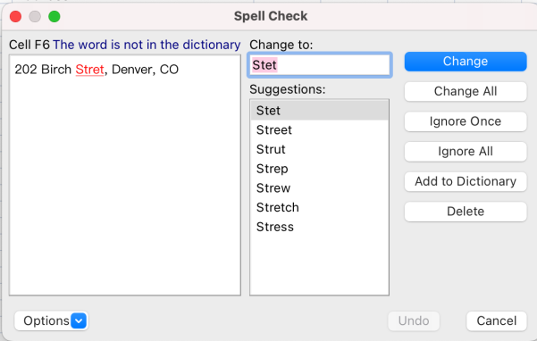You would see that in Address column and 5th row the street spelling is wrong as Stret, it would give you drop down option to change the spelling as from preference or by yourself and then apply to all or simply only that cell change.

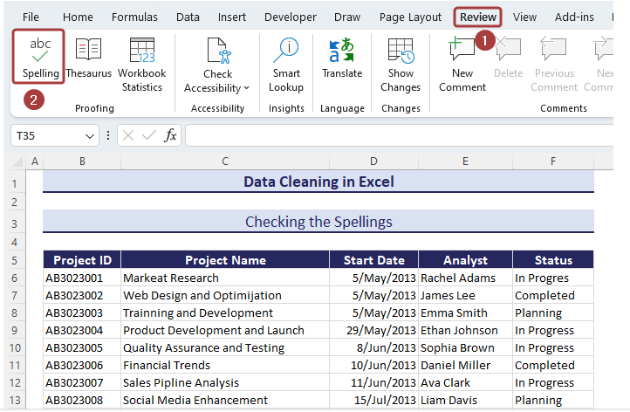

from our table, it would show up spell error of :

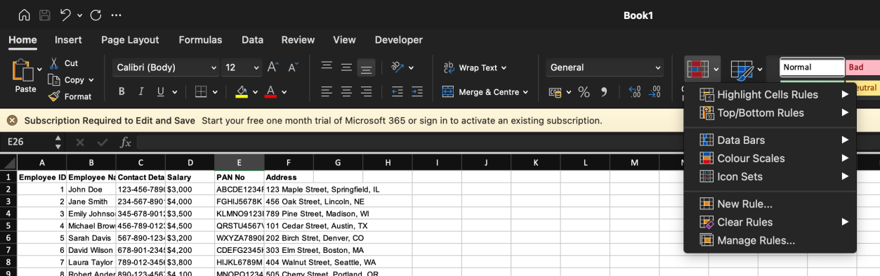**Method 2**: Highlighting Duplicates

* Go to Conditional Formatting from the Home tab.
* Select the New Rule… option.
* Pick the Use a formula to determine which cells to format option from the New Formatting Rule wizard.
* Insert the following formula in the Format values where this formula is true section: **=COUNTIF($C$8:$C$19,$C8)>1,** provide the range from where to find duplicates, and what is duplicate.

Click on the Format option to define Matched Values Format.

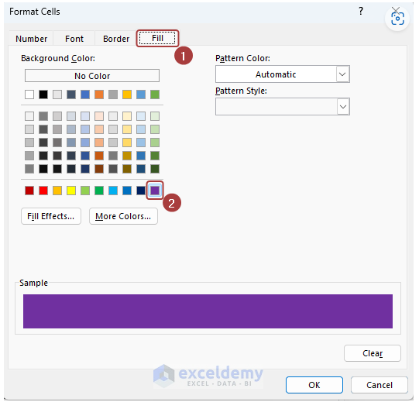

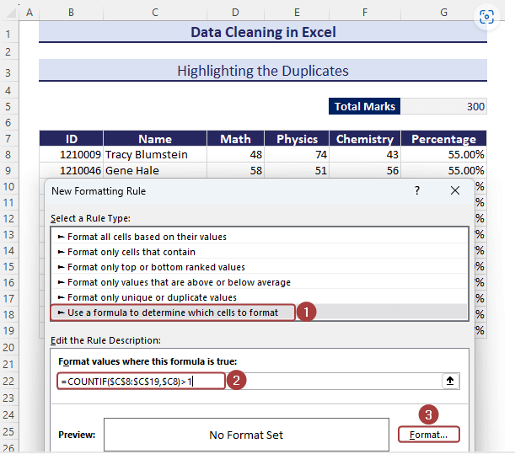

* click on format and select the color range you want to highlight with the duplicates.

**Method 3.** Removing Duplicates

* Select the entire data and go to the Data tab.
* Click on Remove Duplicates.
* select the column or range where you want to remove duplicates.
* Then click on OK.

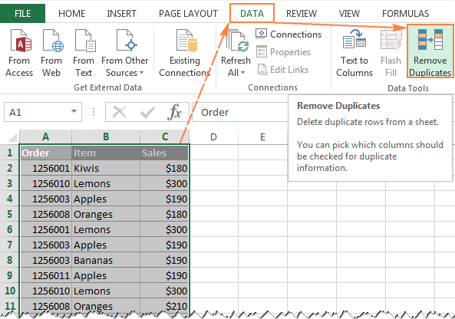

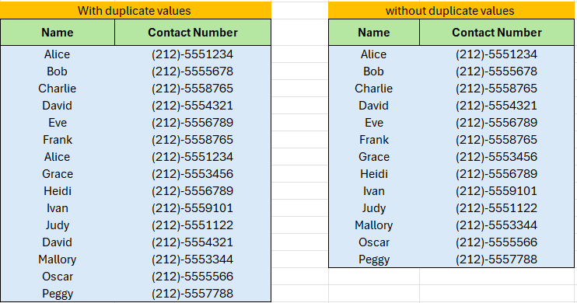

**Practical 8**

Create a data for employee details for ten employees as employee id, employee name, contact details, salary, Pan no and address …apply four methods for data cleaning.

Applying the data cleaning method ahead on the same table created and trying it out the few four methods of them. lets see the table structure first then understand the data cleaning methods.



**Method 1**: Changing Text Cases

* We may create another column where we would apply text cases function like proper on the employee name and show it in its Formal form.
* =PROPER(B2) and then drag it down.
* We may also do this in the same column but still we would need to have reference cell at somewhere to make changes in text cases.

**Method 2:** Removing Spaces

We often unorganized data, where irregular spaces are even more common and so removing them is very important.

* Apply the following formula with the [TRIM](https://www.exceldemy.com/excel-trim-function/), [CLEAN](https://www.exceldemy.com/excel-clean-function/), and [SUBSTITUTE](https://www.exceldemy.com/excel-substitute-function/) functions to remove spaces between texts as well as leading spaces at the beginning:

**=TRIM(CLEAN((SUBSTITUTE(C6,CHAR(160)," "))))**

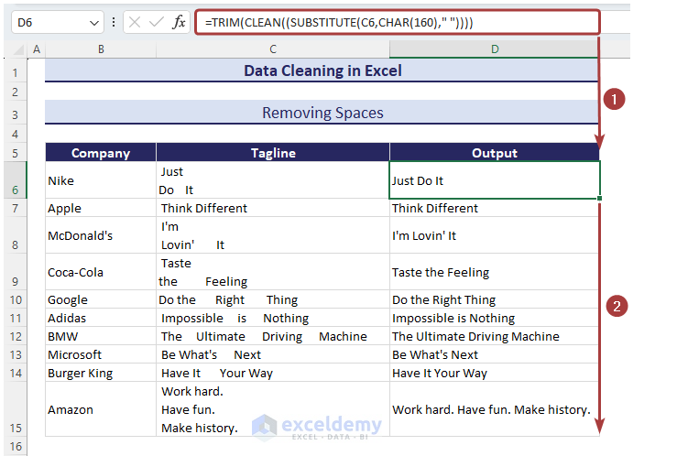

**Method 3:** Removing Non-Printable Character.

To remove non-printable characters in Excel, you can use the CLEAN and TRIM functions. Here's a step-by-step guide:

1. **Using the CLEAN Function**: The CLEAN function removes non-printable characters from text. This function is especially useful for cleaning up imported data that might have non-printable characters.
2. **Using the TRIM Function**: The TRIM function removes extra spaces from text, except for single spaces between words.

### Steps to Remove Non-Printable Characters:

1. **Open your Excel worksheet** and select the cell that contains the text you want to clean.
2. **Create a new column** next to your data if it isn't already available.
3. **Enter the following formula** in the new column, assuming the data you want to clean is in cell A1:

=CLEAN(A1)

**Method 4**: Fixing Numbers

* Use the following formula with [the **VALUE** function](https://www.exceldemy.com/excel-value-function/) to put the numbers in the number format.

**=VALUE(F6)**

**Practical 9**

Create a data for employee details for ten employees as employee id, employee name, contact details, salary, Pan no and address …apply four methods for data cleaning.

As we have already practiced 8 data cleaning methods, lets see some more of the data cleaning methods in excel with the same table in excel.

**Method 1:** Merging Columns

As if we had different columns of address like one of street name, another of pincode, and another of state then we may apply merging columns for proper one line columns. Here is how we can do this:

* Apply the following formula with [the CONCATENATE function](https://www.exceldemy.com/excel-concatenate-function/) to merge the columns and separate the segments with dashes:

=CONCATENATE(C6, “-”, D6, “-”, E6)

|  |  |  |  |  |
| --- | --- | --- | --- | --- |
| **AREA** | **PINCODE** | **STATE** |  | **ADDRESS** |
| Naraina | 110028 | ND | Naraina-110028-ND |
| Pushp Vihar | 110045 | ND | Pushp Vihar-110045-ND |

**Method 2**: Distributing cells content to adjacent columns.

As we did above, now we would need to do just the opposite of what we did before means that now multi value to cell would need to distribute in adjacent columns.

We may create a column where address is separated by ‘-’and so we may apply the steps over tp convert the separated values into column.

|  |
| --- |
| **ADDRESS** |
| Naraina-110028-ND |
| Pushp Vihar-110045-ND |

* Select all the values in the ADDRESS column and click on the Text to Columns option from the Data tab.
* From the Convert Text to Columns Wizard, choose the Delimited since the data is combined with the dash sign.
* Click on Next. And Finish.

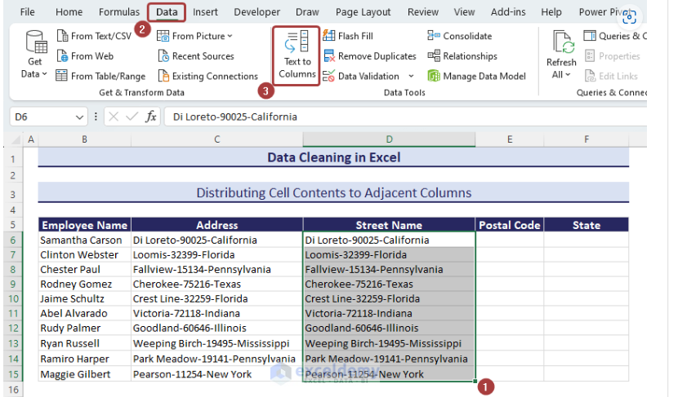

|  |  |  |
| --- | --- | --- |
| **ADDRESS** | **PINCODE** | **STATE** |
| Naraina | 110028 | ND |
| Pushp Vihar | 110045 | ND |

**Method 3** : Switching Rows and Columns

* Copy the entire Range.

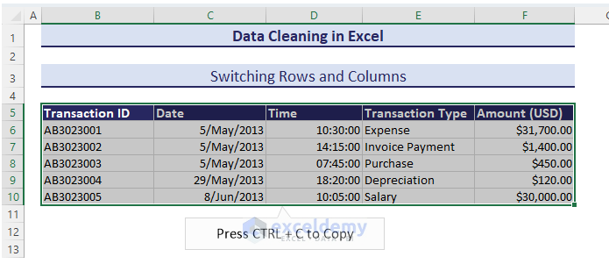

* select a cell to paste the switched rows and columns.
* Go to Paste from the Home tab.
* click on an Empty cell
* Pick the Transpose (T) option to make the switch

|  |  |  |
| --- | --- | --- |
| **ADDRESS** | **PINCODE** | **STATE** |
| Naraina | 110028 | ND |
| Pushp Vihar | 110045 | ND |

|  |  |  |
| --- | --- | --- |
| **ADDRESS** | Saket | Pushp Vihar |
| **PINCODE** | 110028 | 110045 |
| **STATE** | ND | ND |

**Method 4:** Sorting Data

In the following dataset, we will sort data in descending order based on the total marks.

1. Select the column you want to sort by.
2. Go to the Home tab and click on Sort Largest to Smallest from Sort & Filter to sort in descending order.

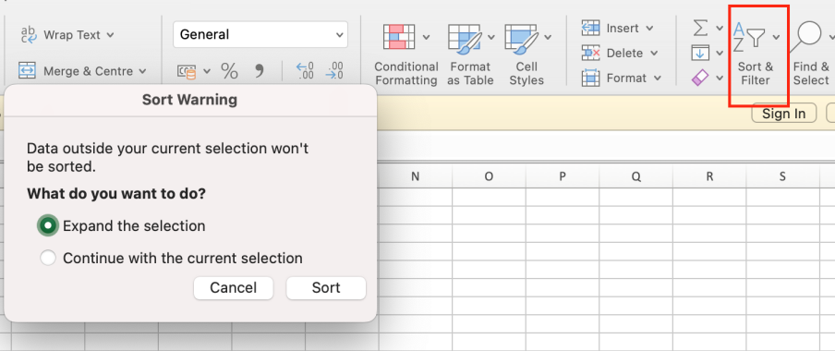

1. Choose Expand the selection and click on Sort.
2. We would find that the table sort accordingly the column and arranges all other columns.

**Method 5:**  Filling Blank Cells

Blank cells make a dataset's unfulfilled. We can insert zeros in those cells to have a better representation.

1. Select the whole range of Data
2. Go to Home Tab
3. Select “Find and Select”.
4. Go to Down and select “Go to special”.
5. Select the “Blank” option

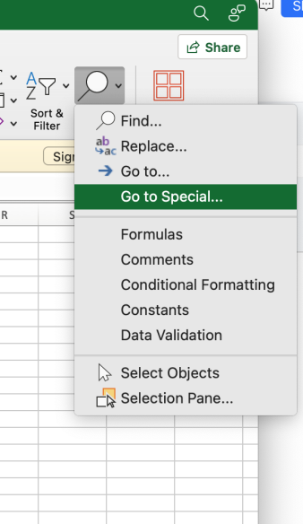

1. Press 0 and click ctrl+enter ( it would add that 0 to all blank cells).

|  |  |  |
| --- | --- | --- |
| **S_Name** | **Roll No** | **Marks** |
| Mani | 101 | 91 |
| Ayush | 102 | 81 |
| Rahul | 103 |  |
| Pawan | 104 | 96 |
| Brishav | 105 | 84 |
| Bhargav | 106 |  |
| Harsh | 107 | 67 |
| Siddharth | 108 |  |

|  |  |  |
| --- | --- | --- |
| **S_Name** | **Roll No** | **Marks** |
| Mani | 233 | 98 |
| Ayush | 231 | 81 |
| Rahul | 677 | 0 |
| Pawan | 453 | 65 |
| Brishav | 432 | 65 |
| Bhargav | 489 | 0 |
| Harsh | 444 | 67 |
| Siddharth | 567 | 0 |

**Practical 10**

Create a data to implement MATCH function and INDEX Function.

**Match Function**

MATCH is an Excel function used to locate the position of a lookup value in a row, column, or table. MATCH supports approximate and exact matching, and wildcards (* ?) for partial matches. Often, MATCH is combined with the INDEX function to retrieve a value at a matched position.

In simple terms it is used to get the position of item in the array.

**Syntax**

=[MATCH](https://exceljet.net/functions/match-function)(lookup_value,lookup_array,[match_type])

For Example, this is the array used:-

|  |
| --- |
| **LUXURY CAR BRANDs** |
| Mercedes |
| Bentley |
| Land Rover |
| BMW |
| Rolls Royce |
| Mesarati |
| Porsche |
| Lamborghini |
| Jaguar |
| Genesis |
| Lotus |
| Volvo |

|  |  |
| --- | --- |
| **Brand** | **Position** |
| Mesarati | 6 |

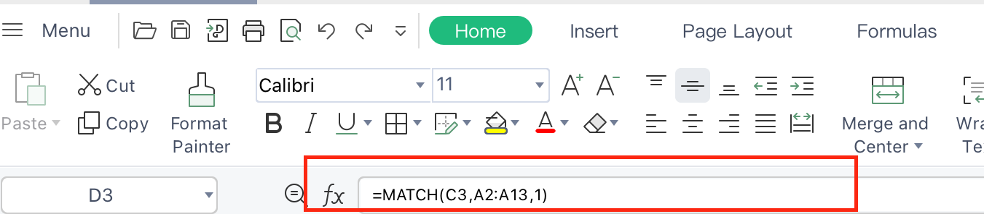

NOTE: Match is not case-sensitive.

**MATCH-INDEX Function:**

The MATCH function is commonly used together with the [INDEX function](https://exceljet.net/functions/index-function). The resulting formula is called "INDEX and MATCH".  For example, in the screen below, INDEX and MATCH are used to return the cost of a code entered in cell F4. The formula in F5 is:

=[INDEX](https://exceljet.net/functions/index-function)(B2:B7,[MATCH](https://exceljet.net/functions/match-function)(F4,A2:A7,1))

lets create table of Product_id and Cost and find the cost with product id.

|  |  |
| --- | --- |
| **Product_ID** | **Cost** |
| SYD-678-TY | ₹234.00 |
| FYT-782-GY | ₹678.00 |
| RTE-564-FF | ₹450.00 |
| FTR-772-VG | ₹780.00 |
| DRT-653-GH | ₹330.00 |
| FGR-764-PT | ₹1,050.00 |

|  |  |
| --- | --- |
| **Cost** | RTE-564-FF |
| **Product_ID** | 450 |

**Practical 11**

Create a data and implement IFNA and IFERROR functions.

**IFNA function in Excel:**

The Excel IFNA function is purposed for catching and handling #N/A errors. If a formula evaluates to #N/A, IFNA traps that error and replaces it with a custom value you specify; otherwise returns a normal result of the formula.

Syntax:

=IFNA(value, value_if_na)

Where:

**Value** (required) - the formula, value, or reference to check for a #N/A error.

**Value_if_na** (required) - the value to return if a #N/A error is detected.

Lets create a table of student name and marks and then get a match function in use, if the somethings

exactly matches then print the position other give the Command you wanna show at the place of

#N/A.

|  |  |  |
| --- | --- | --- |
| **S_Name** | **Roll No** | **Marks** |
| Mani | 233 | 98 |
| Ayush | 231 | 81 |
| Pawan | 453 | 65 |
| Brishav | 432 | 65 |
| Harsh | 444 | 67 |

=IFNA(match(E2, A2:A8,0), “Not Found”)

|  |  |
| --- | --- |
| **Name** | Rahul |
| **Marks** | Not Found |

It is used to Replace very informal written values if nothing found then.

**IFERROR function in Excel:**

The [IFERROR](https://www.ablebits.com/office-addins-blog/excel-iferror-function-formula-examples/) function catches all those errors while IFNA is limited to only #N/A. Which one is better choose? That depends on the situation.If you want to suppress any kind of error, then use the IFERROR function. It is especially useful in complex calculations when a formula includes several functions that can generate different errors.

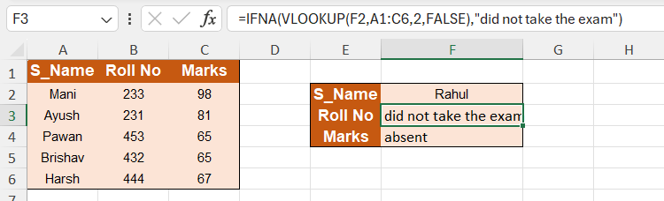

**Practical 12**

Create a data and implement IF, Nested if and Logical function AND and OR with IF.

**Use of IF function:**

IF function is conditional logical function which takes a condition, if it is found true it show true message and otherwise executes the false message.

lets create a table of student name, marks and their status as pass or fail with IF function in Excel. Formula: =IF(B2>32, “Pass”, “Fail”)

|  |  |  |
| --- | --- | --- |
| **Name** | **Marks** | **Status** |
| Aman | 65 | Pass |
| Karan | 82 | Pass |
| Tanish | 27 | Fail |
| Sumit | 47 | Pass |
| Ritesh | 34 | Fail |
| Manish | 58 | Pass |
| Tarun | 22 | Fail |

**Nested IF function use:**

One IF function is capable of performing two actions (the value_if_true and value_if_false ). But if we embed (or nest) another IF function in the value_if_false section, then we can perform another action.

Formula : =IF(B2>=90, “Excellent”, IF(B2>=60, “Good”, “Poor”))

|  |  |  |  |
| --- | --- | --- | --- |
| **Name** | **Marks** | **Status** | **Grade** |
| Aman | 65 | Pass | Good |
| Karan | 82 | Pass | Good |
| Tanish | 97 | Fail | Excelent |
| Sumit | 47 | Pass | Poor |
| Ritesh | 78 | Fail | Good |
| Manish | 58 | Pass | Poor |
| Tarun | 22 | Fail | Poor |

**Logical AND and OR with IF:**

### ****Understanding the Basics:**** Before implementing the functions, it's important to understand the basics of each:

### AND Function: Returns TRUE if all arguments are TRUE.

### OR Function: Returns TRUE if any argument is TRUE.

### IF Function: Returns one value if a condition is TRUE and another value if it's FALSE.

1. **Setup the Data:**

Here we are creating two columns of values in digits and another third column to show the answer using function and formulas about comparing the both columns values:

|  |  |  |  |
| --- | --- | --- | --- |
| **Name** | **Marks1** | **Marks2** | **Grade** |
| Aman | 65 | 45 | Pass |
| Karan | 82 | 87 | Pass |
| Tanish | 97 | 23 | Fail |
| Sumit | 47 | 68 | Pass |
| Ritesh | 78 | 92 | Pass |
| Manish | 58 | 31 | Pass |
| Tarun | 22 | 76 | Fail |

formula : =IF(AND(C14>30,D14>30),"Pass","Fail")

**Now using OR logical function:**

We would go with the same table but now show the greater than 10 if any one column has even greater than10 number digit.

|  |  |  |  |
| --- | --- | --- | --- |
| **Name** | **Marks1** | **Marks2** | **Grade** |
| Aman | 65 | 45 | Pass |
| Karan | 82 | 87 | Pass |
| Tanish | 97 | 23 | Pass |
| Sumit | 47 | 68 | Pass |
| Ritesh | 78 | 92 | Pass |
| Manish | 58 | 31 | Pass |
| Tarun | 22 | 76 | Pass |

formula : =IF(OR(C14>30,D14>30),"Pass","Fail")